
Cyber Security Masters

2 | www.simplilearn.com

Table of Contents

About the Course
03

Key Features of
04
Cyber Security Master’s Program

05 Learning Path

06 Step 1 : CompTIA Security+ 501

08 Step 2 : Certified Ethical Hacker

11 Step 3 : CISM

13 Step 4 : CISSP

15 Step 5 : CCSP

17 Electives




About the Course
The Cyber Security Master’s Program will equip you with the full range of skills needed to become an expert in this rapidly growing domain. You will learn comprehensive approaches to protecting your infrastructure, including securing data and information, running risk analysis and mitigation, architecting cloud-based security, achieving compliance and much more with this best-in-class program.





The Master’s Cyber Security Program helps you develop the key skills necessary to become a Cyber Security Expert.

Key Features
 96+ hours of instructor-led online classes  64+ hours of e-learning content
 Exam voucher included for CEH and CompTIA Security+
Master’s Certificate upon course completion

Learning Path

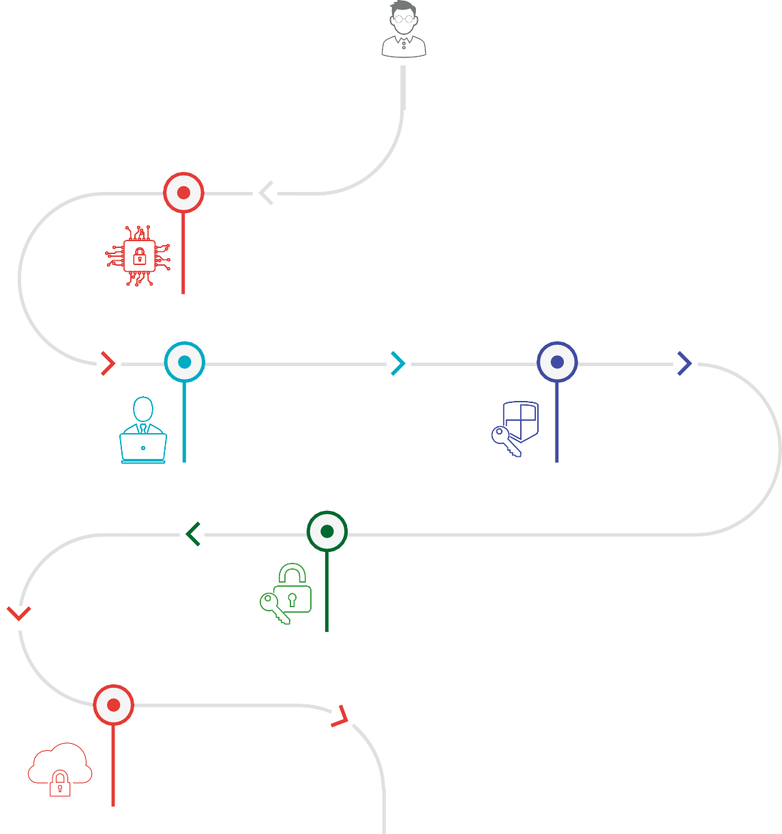
Masters Certificate You will get individual certificates for each
CompTIA Security+ 501
CEH (V10) -
Certified Ethical Hacker
CISM®
CISSP®
CCSP -
Certified Cloud Security Professional

Cyber Security Master’s Program

STEP
1
2
3
4
5
CompTIA Security+ 501
The CompTIA Security+ course will enable learners to gain knowledge and skills required to install

and configure systems to secure applications, networks, and devices; perform threat analysis and respond with appropriate mitigation techniques; participate in risk mitigation activities; operate with an awareness of applicable policies, laws, and regulations. Upon successfully validating their skills by passing the certification exam learners will be able to perform these tasks to support the principles of confidentiality, integrity, and availability. CompTIA Security+ meets the ISO 17024 standard and is approved by the U.S.

Key Learning Objectives
After completing this course you will be able to: Comprehend risk identification and mitigation Provide operational, information, application
and infrastructure level security
Secure the network to maintain the availability, integrity and confidentiality of critical information
Operate within a set of rules, policies and regulations wherever applicable

Course curriculum
Lesson 01 - Learn about networking, firewalls, LAN security, IDS, NAC, IPSec
Lesson 02 - Understand the principles of security, risk management, data classification, disaster recovery, and forensics
Lesson 03 - Comprehend cyber attacks, DNS security, social engineering fundamentals, buffer overflows, security testing tools usage, honeypots, vulnerability and pen testing
Lesson 04 - Learn how to handle bugs, secure storage platforms and the power grid, how to hack IOT
Lesson 05 - Get familiar with access controls, Kerberos, identity federation, and id governance








Lesson 06 - Encryption, advanced cryptography, crypto algorithm, PKI, etc are covered in this lesson

STEP
1
2
3
4
5

CEH
The Simplilearn’s CEH v10 Certified Ethical Hacker training (earlier CEH v9) and certification course provide hands-on classroom training to help you master the same techniques that hackers use to penetrate network systems and leverage them ethically to protect your own infrastructure.
The extensive course focuses on 20 of the most popular security domains to provide a practical approach to essential security systems.

Key Learning Objectives
After completing this course you will be able to: Ace the CEH practical exam
Learn to assess computer system security by using penetration testing
techniques
Scan, test and hack secure systems and applications, and gain hands- on experience with sniffing, phishing and exploitation tactics

Course Curriculum
Module 01: Introduction to Ethical Hacking - Overview of information security, threats, attack vectors, ethical hacking concepts, information security controls, penetration testing concepts, and information security laws and standards are covered in this module
Module 02: Footprinting and Reconnaissance - These modules cover concepts and types of footprinting, footprinting through search engines, web services, and social networking sites, footprinting tools, countermeasures, and footprinting pen testing

Module 03: Scanning Networks - Learn about network scanning concepts, tools and techniques, network diagrams, and scanning pen testing
Module 04: Enumeration - Enumeration concepts, types, techniques, and pen testing are covered in this module
Module 05: Vulnerability Analysis - Overview of vulnerability assessment concepts, solutions, scoring systems, tools, and reports are explained in this module
Module 06: System Hacking - Learn how to crack passwords, hide files, cover tracks, any many more
Module 07: Malware Threats - This module gets you familiar with malware concepts, trojan concepts, malware analysis, countermeasures, malware penetration testing
Module 08: Sniffing - Sniffing concepts, tools, and techniques are explained in this module
Module 09: Social Engineering - Comprehend social engineering concepts, techniques, countermeasures, and pen testing
Module 10: Denial-of-service - Dos/DDoS concepts, techniques, tools, case studies, and penetration testing are covered in this module
Module 11: Session Hijacking - Know what is session hijacking and its types, tools, countermeasures, and session hijacking penetration testing
Module 12: Evading IDS, Firewalls, and Honeypots - Learn about firewalls and honeypots and how to detect and evade them
Module 13: Hacking Web Servers - This module focuses on web server concepts, attacks, methodologies, tools, countermeasures, and penetration testing
Module 14: Hacking Web Applications - Web app concepts, tools, methodologies, countermeasures, and penetration testing are covered in this module

Module 15: SQL Injection - Get familiar with SQL Injection concepts, types, tools, methodologies, countermeasures, and penetration testing
Module 16: Hacking Wireless Networks - Wireless concepts, threats, methodologies are covered in this module
Module 17: Hacking Mobile Platforms - Learn how to hack android IOS, Mobile spyware, device management, security tools, and many more in this module
Module 18: IoT Hacking - This module covers IoT Hacking concepts, attacks, methodologies, tools, countermeasures, and penetration testing
Module 19: Cloud Computing - Concepts, attacks, methodologies, tools, countermeasures, and penetration testing of cloud computing are covered in this module
Module 20: Cryptography - This module will teach you about cryptography concepts, encryption algorithms, tools, PKI, types of encryption, cryptanalysis, and countermeasures










STEP
1
2
3
4
5

CISM
This CISM certification training from Simplilearn will give you the requisite skill sets to design, deploy and manage security architecture for your organization. The course is aligned with ISACA best practices and is designed to help you pass the CISM exam on your first attempt.

Key Learning Objectives
After completing this course you will be able to:
Define and design security architecture for your IT operation
Develop a working knowledge of the four domains prescribed by the ISACA Exam Candidate Information Guide 2015
Demonstrate a deep understanding of the relationship between information security programs and broader business goals and objectives.
Focus on IT compliance and the integrity of enterprise systems to establish a more secure enterprise IT framework
Earn the requisite 16 CPEs required to take the CISM certification exam Acquire the relevant knowledge and skills required to pass the CISM
certification exam

Course curriculum
Lesson 01: Information Security Governance - Understand the broad requirements for effective information security governance, the elements and actions required to develop an information security strategy, and be able to formulate a plan of action to implement this strategy.
Lesson 02: Information Risk Management and Compliance - Establish a process for information asset classification and ownership and Identify legal, regulatory, organizational and other applicable requirements to ensure that risk assessments, vulnerability assessments, and threat analysis are conducted periodically.
Lesson 03: Information Security Program Development and Management - Develop and manage an information security plan.

Lesson 04: Information Security Incident Management - Manage information security within an enterprise and develop policies and procedures to respond to and recover from disruptive and destructive information security events.

STEP
1
2
3
4
5
CISSP

Simplilearn’s CISSP certification training is aligned with the (ISC)2 CBK 2018 requirements. The course trains you in the industry’s latest best practices, which will help you pass the exam
in the first attempt. The certification helps you develop expertise in defining the architecture and in designing, building, and maintaining a secure business environment for your organization using globally approved Information Security standards.

Key Learning Objectives
Be able to define the architecture, design and management of the security of your organization.
Acquire the relevant knowledge and skills required to pass the CISSP certification exam.
Earn the requisite 30 CPEs required to take up the CISSP certification exam.
Develop working knowledge in the 8 domains prescribed by the CISSP Common Book of Knowledge, 2018.

Course curriculum
Lesson 00: Introduction to CISSP - Overview of CISSP, CISSP Exams, ISC2 is covered in this lesson
Lesson 01: Security and Risk Management - Information security management, risk analysis, legal systems, IP laws, BCA, CIA, etc are covered in this lesson
Lesson 02: Asset Security - Learn how to classify information, protect privacy, maintain ownership, establish handling requirements
Lesson 03: Security Engineering - Understand security engineering processes using secure design principles, Architecture Frameworks, Security Models Evaluation Criteria, Distributed Systems, and many more
Lesson 04: Communications and Network Security - Learn how to secure network architecture, design, components, and communication channels
Lesson 05: Identity and Access Management - Implement and manage authorization mechanisms to prevent or mitigate access control attacks
Lesson 06: Security Assessment and Testing - Learn how to design and validate assessment and test strategies
Lesson 07: Security Operations - Understand and support requirements for investigations by implementing resource protection techniques and incident response
Lesson 08: Software Development Security - Comprehend the system life cycle and system development in this lesson

STEP
1
2
3
4
5
CCSP

Simplilearn’s online CCSP training course will help you gain expertise in cloud security architecture, design, applications, and operations. CCSP by ISC2 is a globally acknowledged certification which represents the highest standard for Cloud security. This course provides step by step guidance and easy-to-follow detailed explanation on every facet of CCSP.

Key Learning Objectives
After completing this course you will be able to:
Gain a firm foothold on Cloud computing and relevant security concepts
Comprehend design principles of secure Cloud computing Know about Cloud data lifecycle
Design Cloud data storage architectures and security strategies, and implement them effectively
Apply data discovery and classification technologies
Create and execute relevant jurisdictional data protection for personally identifiable information
Plan and implement data retention deletion archival policies
Learn about Cloud infrastructure components and analyze risks associated with it
Recognize the need for training and awareness in application security

Understand Software Development Lifecycle (SDLC) process and apply it
Frame appropriate Identity and Access Management (IAM) solutions Build and run logical and physical architectures for Cloud
Acquire an understanding of legal requirements, privacy issues, and audit process methodologies within the Cloud environment

Course curriculum
Domain 01: Architectural concepts and design requirements - Understand cloud computing concepts, cloud reference architecture, design principles of secure cloud computing
Domain 02: Cloud Data Security - Comprehend and apply Cloud Data Lifecycle, data security strategies, data discovery and classification technologies, data rights management, and many more
Domain 03: Cloud Platform and Infrastructure Security - Analyze risks associated to cloud infrastructure, design and plan security controls and disaster recovery
Domain 04: Cloud Application Security - Learn about Software Development Life-cycle(SDLC) process, specifics of cloud application architecture, and many more in this domain
Domain 05: Operations - Build, implement, and manage physical infrastructure for Cloud environment
Domain 06: Legal and Compliance - Understand legal requirements, privacy issues, audit process, cloud contract design

Elective Course

CISA - Certified Information Systems Auditor
The Certified Information Systems Auditor (CISA) course will give you the requisite skill sets to govern and control enterprise IT and perform an effective security audit on any organization. You’ll gain expertise in the acquisition, development, testing, and implementation of information systems and learn the guidelines, standards and best practices of protecting them. CISA is one of the hottest areas in information security, with a need for six million IT security professionals by 2019.

CompTIA Network+
CompTIA Network+ is an ISO-17024 compliant, vendor-neutral technology certification that verifies the skills and knowledge of a certified individual to take on a pivotal role in building, managing, and protecting the
critical asset i.e. the data network. The CompTIA Network+ course from Simplilearn covers the objectives of the Network+ exam N10-006 and focuses mainly on the IT skills mostly used by the IT professionals. It also covers topics on troubleshooting, security knowledge, and security controls.



